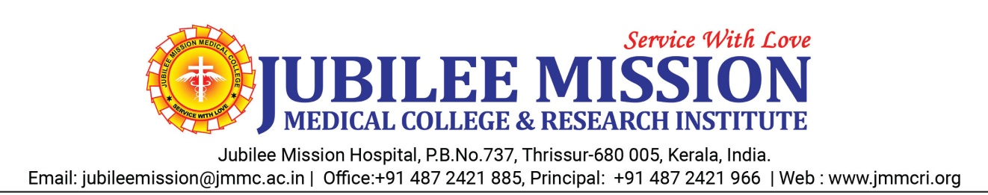
Information as per clause B.1.11
MBBS course started in 2003 - Calicut University, with an annual intake of 100 Students

2010 - Kerala University of Health Sciences, Thrissur

2025 – Seat Increased from 100 to 150

PG Seats

Sl No | Subject | No of seats
1 | General Medicine | 4
2 | Radiodiagnosis | 3
3 | ENT | 3
4 | Orthopedics | 3
5 | Anaesthesiology | 4
6 | Paediatrics | 4
7 | Microbiology | 2
8 | Pathology | 3
9 | Gynaecology | 4
10 | Ophthalmology | 2
11 | Emergency Medicine | 3
12 | Transfusion Medicine | 2
13 | General Surgery | 5
14 | Psychiatry | 3
15 | Physiology | 1
16 | Community Medicine | 2
17 | Dermatology | 2
18 | Pulmonary Medicine | 2
 | Total | 52
Super specialty - PG(DM) Seats & Date of Recognition

Sl No | Subject | Date of Recognition | No of seats
1 | Cardiology | 2013 | 3
2 | Neurology | 2013 | 4
3 | Critical Care Medicine | 2024 | 2
 | Total |  | 9

